🔐 PortSwigger Lab: Basic SSRF Against the Local Server

🧪 Lab Overview
Platform: PortSwigger Web Security Academy
Lab: Basic SSRF against the local server
Difficulty:Apprentice
Vulnerability:Server-Side Request Forgery (SSRF)
Status:✅ Solved

Objective
The application contains a **stock check** feature that fetches stock information from an internal system.
The objective of this lab is to abuse the `stockApi` parameter to make the server send a request to the internal admin interface:
http://localhost/admin
After accessing the internal admin interface through SSRF, the goal is to identify the delete endpoint and delete the user:
carlos
What is SSRF?
Server-Side Request Forgery (SSRF) is a vulnerability where an attacker can manipulate a server-side request to access resources that should not normally be accessible to the attacker.
For example:
Attacker → Public Web Application → Internal Server
↓
http://localhost/admin
The important point is that the request is made by the vulnerable server, not directly by the attacker's browser.

🧠 How I Approached the Problem
I followed a step-by-step approach to understand how the stock check functionality communicates with the backend.
My approach was:
- Open the PortSwigger lab.
- Explore the application and identify the stock check functionality.
- Check the normal stock response.
- Configure FoxyProxy to route browser traffic through Burp Suite.
- Enable Burp Suite Proxy Intercept.
- Capture the stock check request.
- Send the request to Burp Repeater.
- Examine the stockApi parameter.
- Replace the original stock API URL with:
- http://localhost/admin
- Observe that the server returned the internal administration interface.
- Inspect the returned HTML to identify the delete endpoint.
- Identify the endpoint:
- http://localhost/admin/delete?username=carlos
- Submit the delete URL through the stockApi parameter.
- Follow the redirection.
- Verify that the lab was solved.
- Finally, check the admin page again and confirm that carlos was no longer listed.
This demonstrated that the server could be used as a proxy to access its own internal admin interface.

📸 Screenshot-by-Screenshot Explanation
Screenshot 1 — Lab Description
The first screenshot shows the PortSwigger Web Security Academy lab:
Basic SSRF against the local server
The lab is marked as Apprentice and the objective is clearly provided.
The application has a stock check feature that fetches data from an internal system.
The goal is to change the stock check URL so that the application accesses:
http://localhost/admin
The final objective is to delete the user:
carlos
This immediately indicates that the stock check functionality may be capable of making server-side requests to other locations.
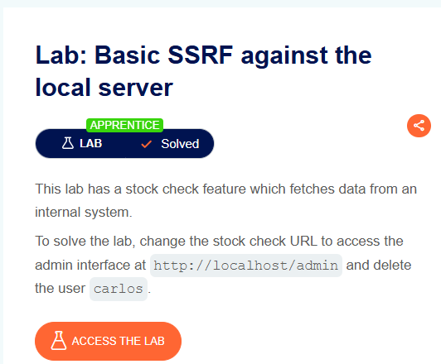
Screenshot 2 — Accessing the Lab
After clicking Access the Lab, the vulnerable web application opens.
The application provides a shopping-style interface where products can be viewed.
At this stage, the main goal is to explore the available functionality and identify any feature that communicates with another server or URL.
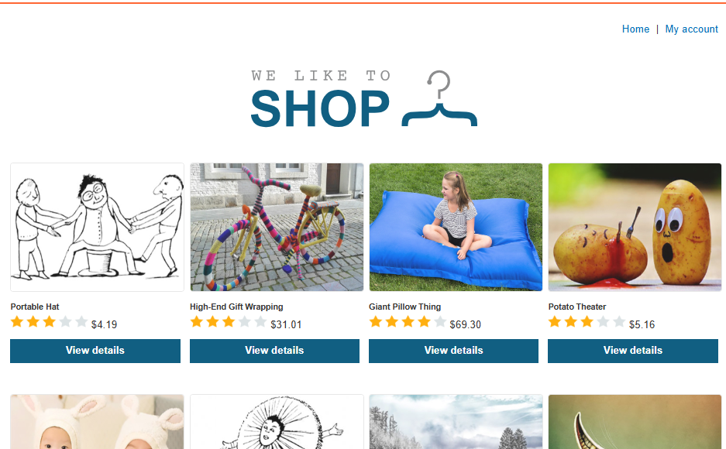
Screenshot 3 — Identifying the Stock Check Functionality
After opening a product, I explored the available functionality.
I found a Check stock feature.
This functionality is interesting because the lab description says that the application fetches stock information from an internal system.
A feature that fetches data from another URL can potentially become an SSRF attack surface if the destination URL can be controlled.
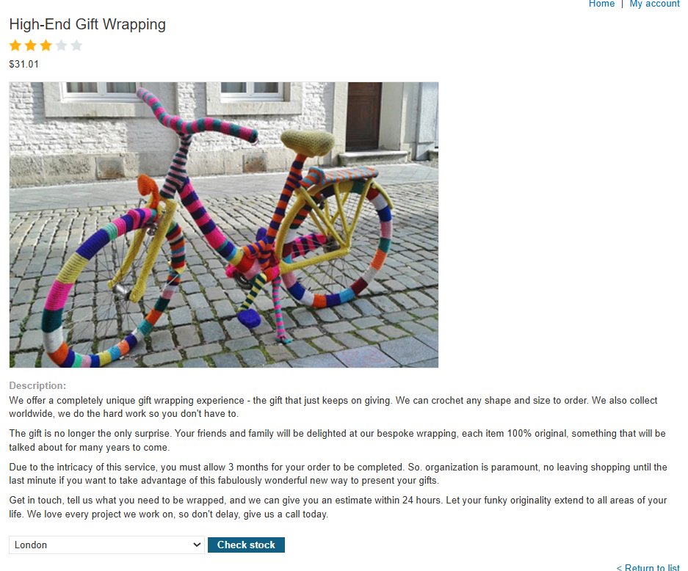
Screenshot 4 — Checking the Normal Stock Response
I clicked the Check stock button to observe the normal behavior.
The application returned:
708 units
This confirmed that the stock check functionality was successfully communicating with the backend system.
At this point, I wanted to capture the request and inspect how the application was obtaining the stock information.
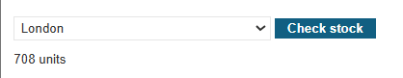
Screenshot 5 — Configuring FoxyProxy
To capture the browser request in Burp Suite, I enabled the FoxyProxy browser extension.
FoxyProxy allows the browser traffic to be routed through the Burp Suite proxy.
The proxy was configured so that requests from the browser could be intercepted and analyzed.
This is useful during web security testing because it allows us to inspect parameters and modify requests before they reach the server.
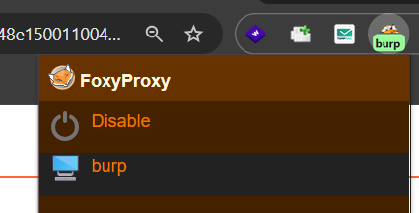
Screenshot 6 — Enabling Burp Suite Intercept
I opened Burp Suite and selected the Proxy tab.
Then I enabled:
Intercept on
With interception enabled, Burp Suite can capture HTTP requests generated by the browser.
The next step was to trigger the stock check request again so that it would appear inside the Burp Proxy Intercept tab.
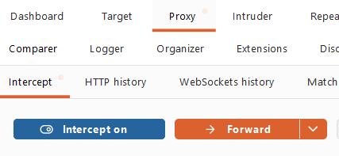
Screenshot 7 — Capturing the Stock Check Request
After refreshing the browser and triggering the stock check functionality, Burp Suite captured the request.
The request was:
POST /product/stock
The important part of the request was the body parameter:
stockApi=
The value contained an encoded URL pointing to the stock service.
This was the key parameter because the lab specifically instructs us to change the URL in stockApi.
After checking the host and request, I sent the request to Burp Repeater for further testing.
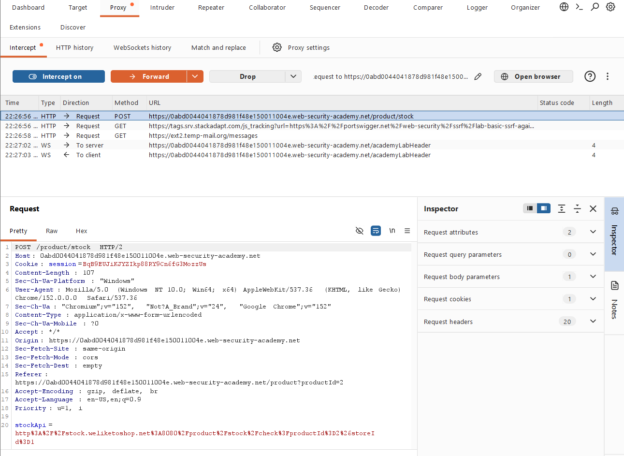
Screenshot 8 — Testing the Original Stock API
In Burp Repeater, I sent the captured request without making the SSRF modification first.
The server returned:
HTTP/2 200 OK
The response contained the stock value:
714
The request also contained the stockApi parameter.
This confirmed that the application accepts a URL through the stockApi parameter and uses it to retrieve information.
That behavior made the parameter a strong candidate for SSRF testing.
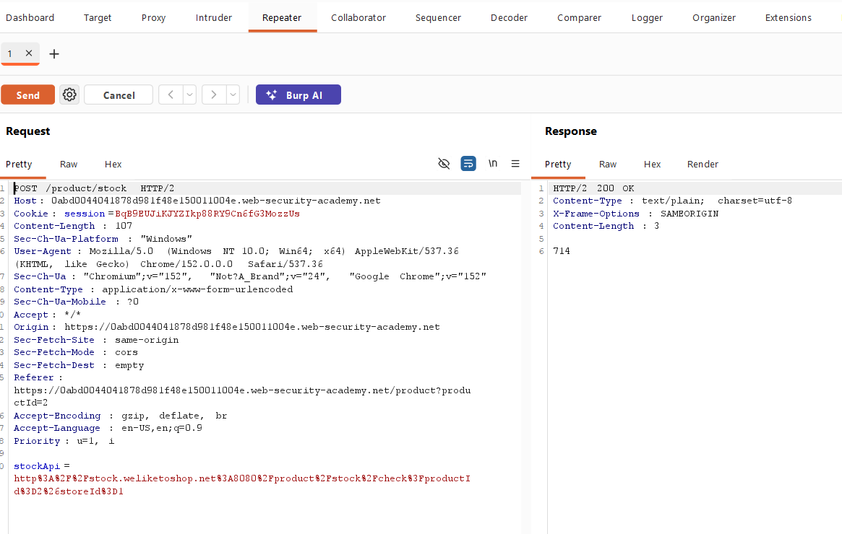
Screenshot 9 — Changing the Stock API to Localhost
The lab description instructed me to change the URL in the stockApi parameter to:
http://localhost/admin
I modified the parameter accordingly and sent the request.
The server returned:
HTTP/2 200 OK
This was an important result.
It showed that the application was able to make a request to the internal localhost address on my behalf.
This is the core behavior of the SSRF vulnerability.
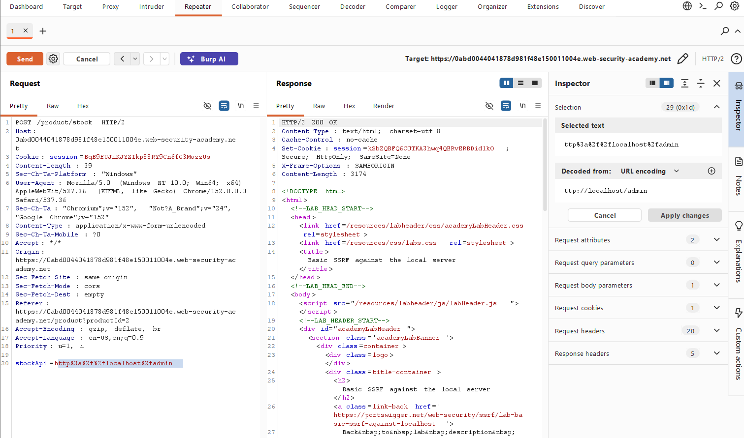
Screenshot 10 — Rendering the Internal Admin Interface
To understand the response more clearly, I selected the Render option in Burp Repeater.
The rendered response displayed the internal administration interface.
It contained:
Admin panel
and a list of users.
The users shown included:
wiener
carlos
This confirmed that the SSRF request successfully reached the internal admin interface.
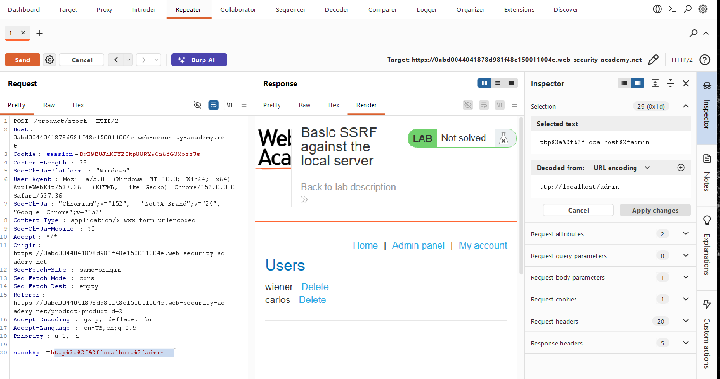
Screenshot 11 — Opening the Response in Browser
I right-clicked on the response and selected:
Open response in browser
Burp Suite provided a URL that could be opened in a browser configured to use Burp Suite as its proxy.
The purpose of this step was to view the server response directly in a browser rather than only inside Burp Repeater.
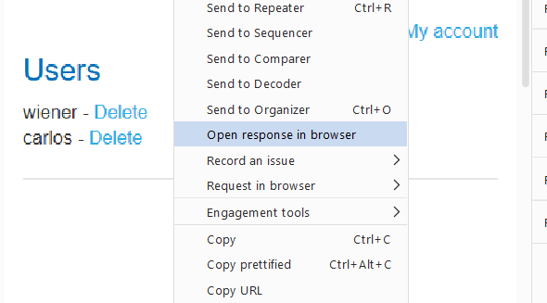
Screenshot 12 — Copying the Burp Response URL
Burp Suite displayed the generated response URL.
I copied this URL so that I could open the rendered response in the browser.
This allowed me to inspect the internal admin page in a browser view.
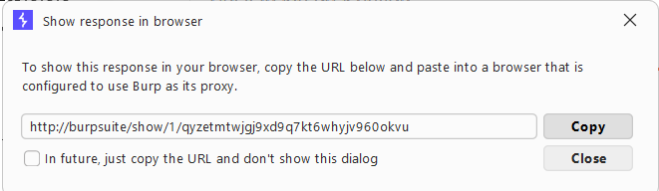
Screenshot 13 — Viewing the Internal Admin Panel
After opening the generated URL in the browser, the internal administration interface was displayed.
The page showed:
Users
with:
wiener - Delete
carlos - Delete
This was significant because the external application did not directly allow access to this internal admin functionality.
The SSRF vulnerability allowed the application's server-side request to access it.
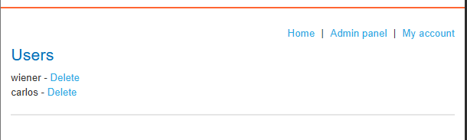
Screenshot 14 — Direct Delete Attempt
I clicked the delete functionality for carlos.
The application responded with:
Admin interface only available if logged in as an administrator, or if requested from loopback
This message revealed an important security condition.
The admin interface allows requests when they originate from the loopback interface.
This is exactly why SSRF is useful in this lab.
The vulnerable stock check functionality can make requests from the server itself, allowing the request to appear as though it originated from the local system.
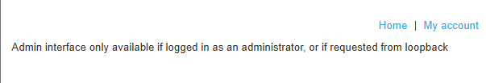
Screenshot 15 — Finding the Delete Endpoint
I returned to Burp Repeater and inspected the raw response.
By searching through the HTML, I found the delete endpoint for the target user:
/admin/delete?username=carlos
The complete internal URL is:
http://localhost/admin/delete?username=carlos
This was the endpoint required to delete the user.
The important discovery was that the delete functionality was represented as a URL, which meant it could also be supplied through the SSRF-controlled stockApi parameter.
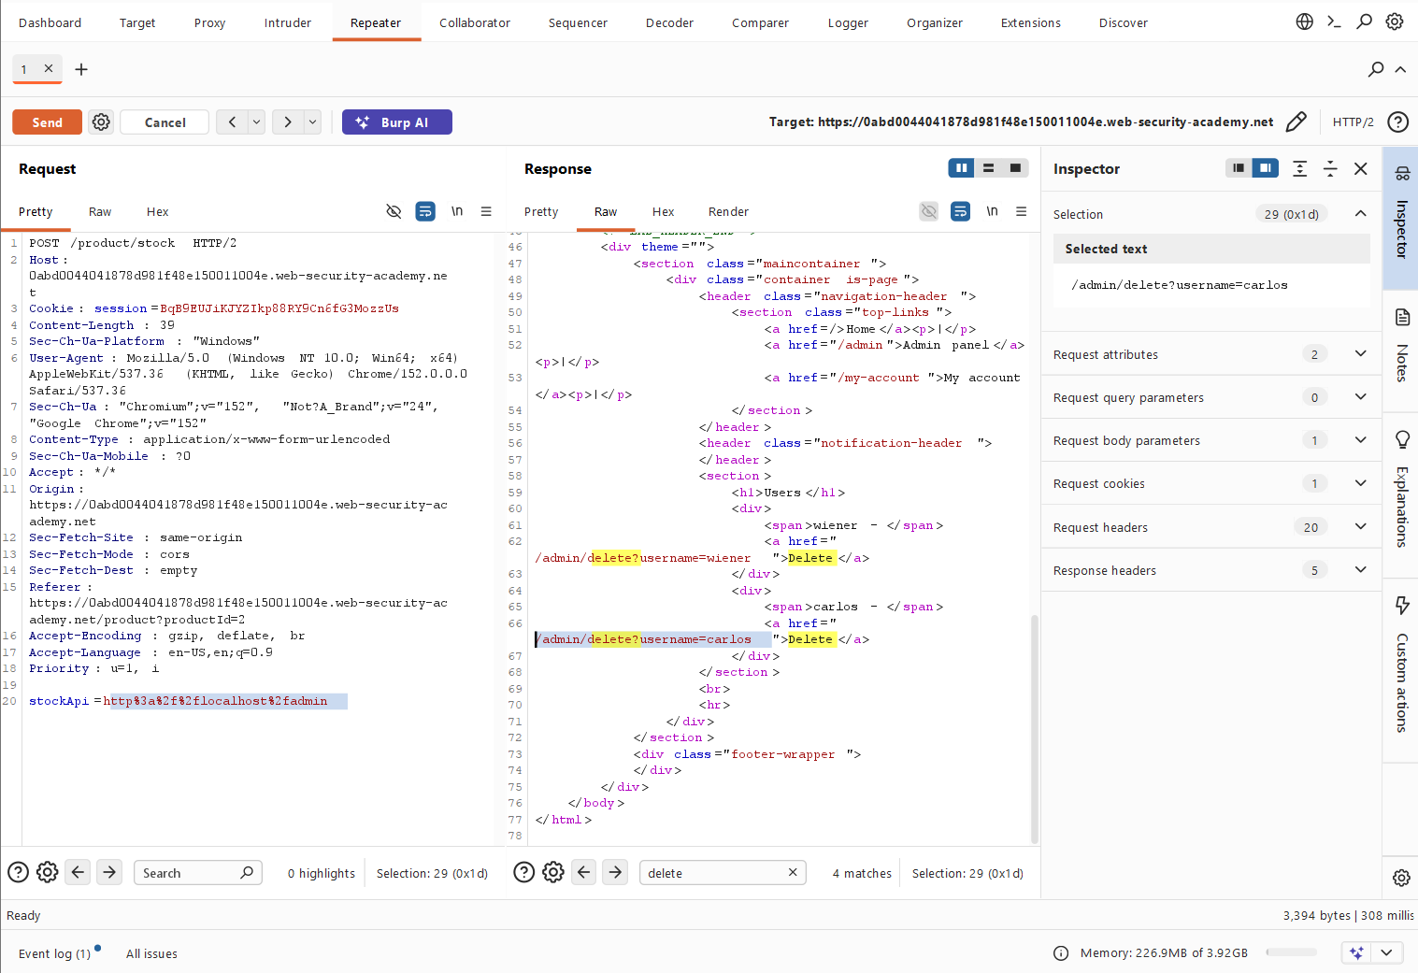
Screenshot 16 — Supplying the Delete URL Through stockApi
I modified the stockApi parameter so that the server would request the internal delete endpoint:
http://localhost/admin/delete?username=carlos
The URL was URL-encoded inside the request.
The important idea here was:
stockApi
↓
http://localhost/admin/delete?username=carlos
↓
Server makes the request
↓
Internal admin functionality
I then applied the changes and sent the request from Burp Repeater
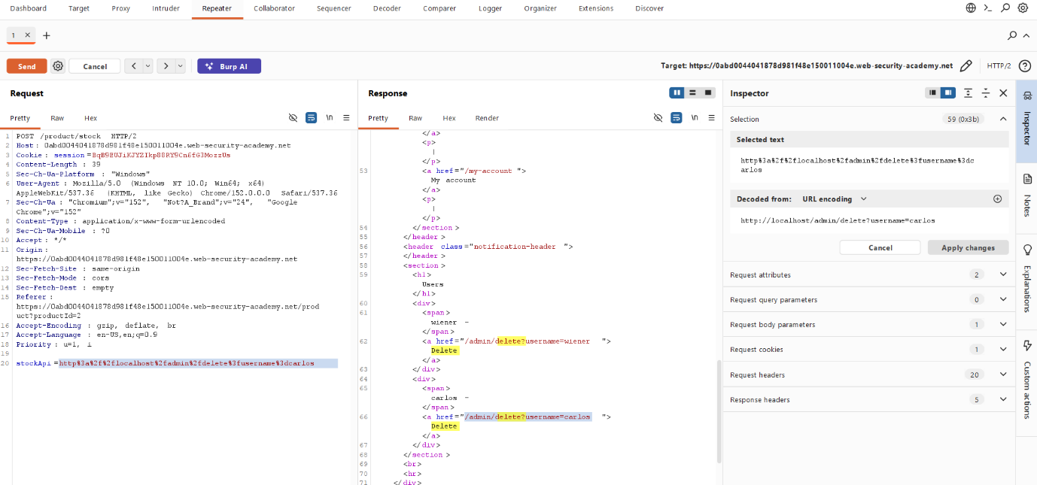
Screenshot 17 — Following the Redirection
After sending the modified request, the server returned a redirection response:
HTTP/2 302 Found
The response contained:
Location: /admin
I selected Follow redirection to continue following the server's response.
This allowed me to observe what happened after the delete request.
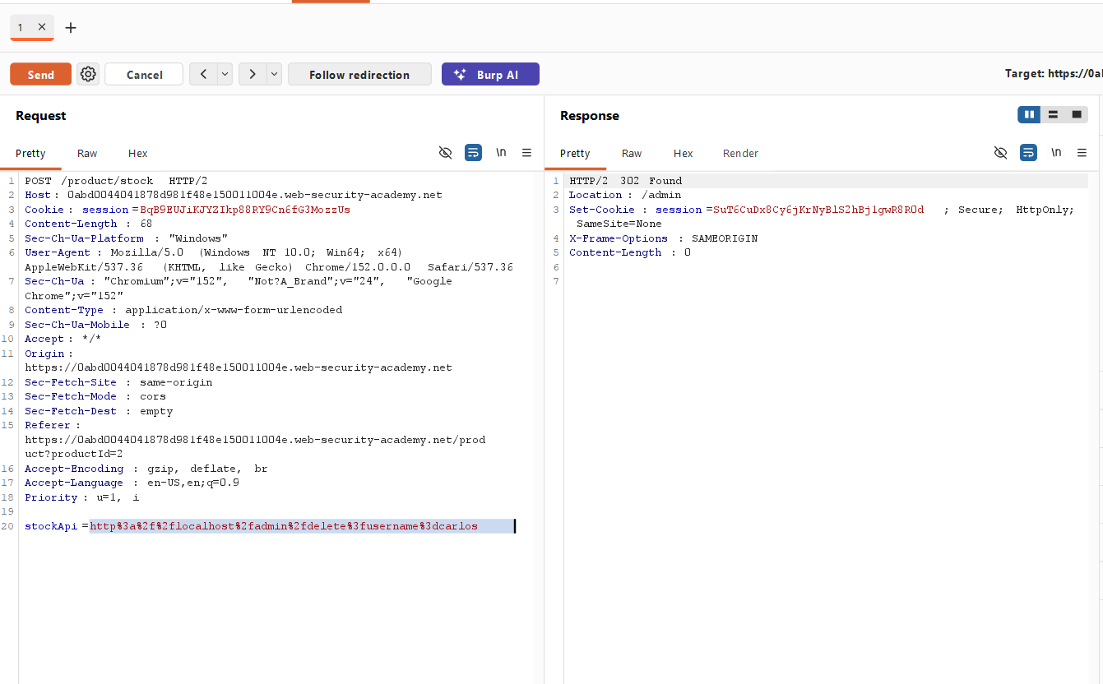
Screenshot 18 — 401 Unauthorized Response
After following the redirection, the response showed:
HTTP/2 401 Unauthorized
At first, this may appear confusing because the previous SSRF request successfully accessed the internal admin interface.
However, the important point is that the SSRF request and the subsequent browser/request flow are not necessarily treated as the same request context.
The previous SSRF request had already demonstrated access to the loopback-protected functionality.
The next step was to inspect the response in rendered form and check the lab status.
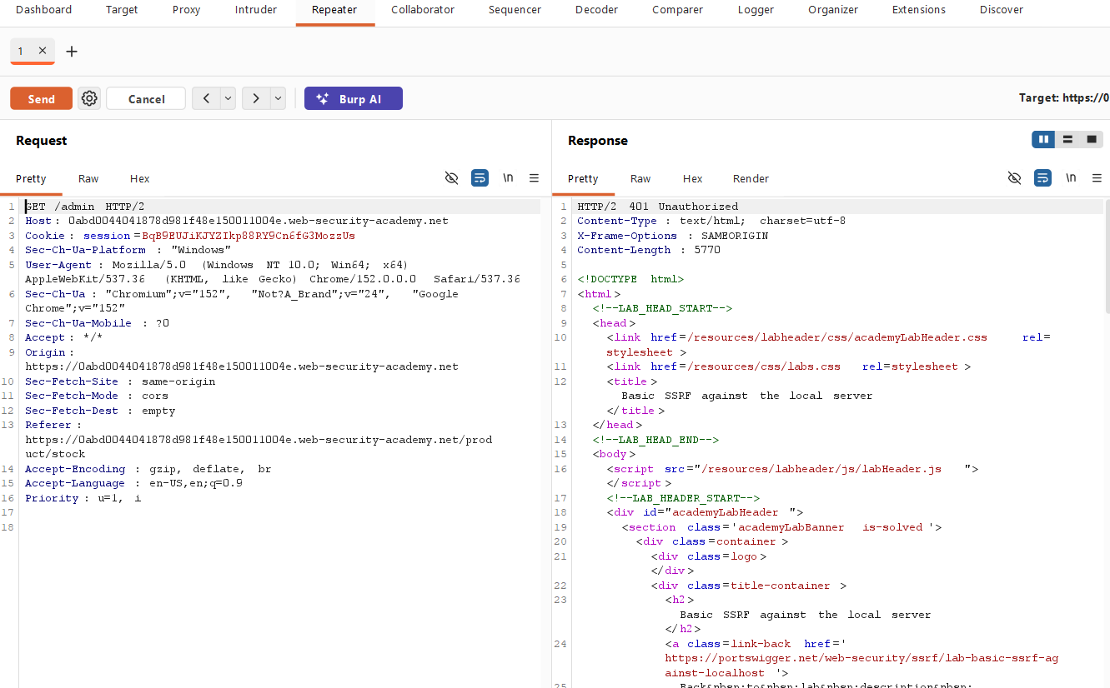
Screenshot 19 — Lab Successfully Solved
I selected the Render option to view the response in a browser-like format.
The PortSwigger lab status showed:
LAB Solved
This confirmed that the delete request successfully achieved the lab objective.
The target user carlos had been successfully deleted.
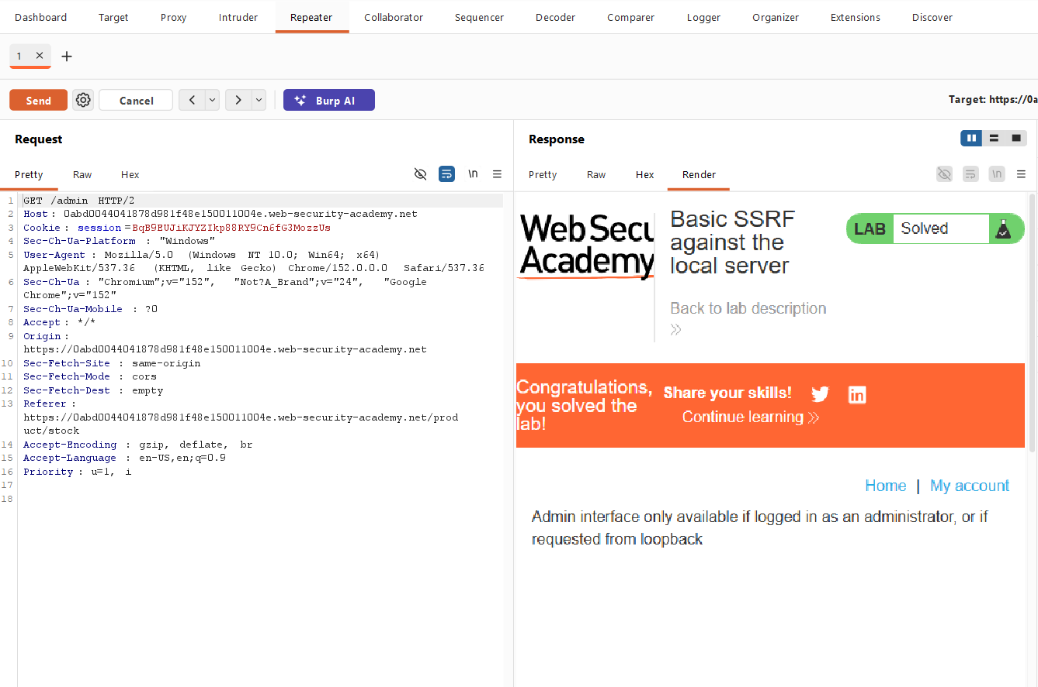
Screenshot 20 — Confirming the Solved Lab in Browser
I also opened the response in the browser.
The browser displayed the solved lab state.
This provided an additional visual confirmation that the PortSwigger lab recognized the successful exploitation.
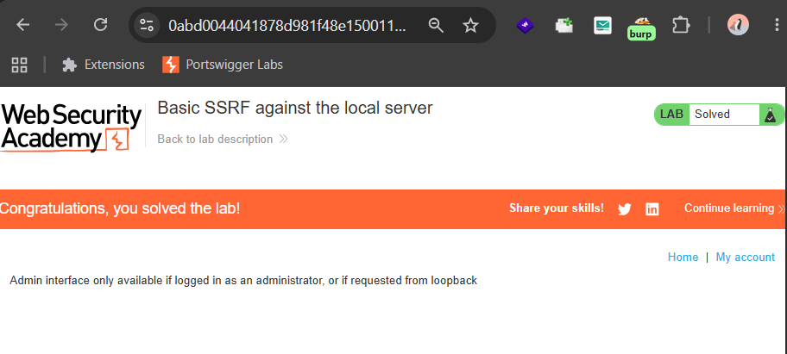
Screenshot 21 — Final Verification of User Deletion
For final confirmation, I changed the SSRF URL back to:
http://localhost/admin
and sent the request again.
In the rendered response, the admin page no longer displayed:
carlos
This confirmed that the user had actually been deleted.
Therefore, the lab was successfully completed.
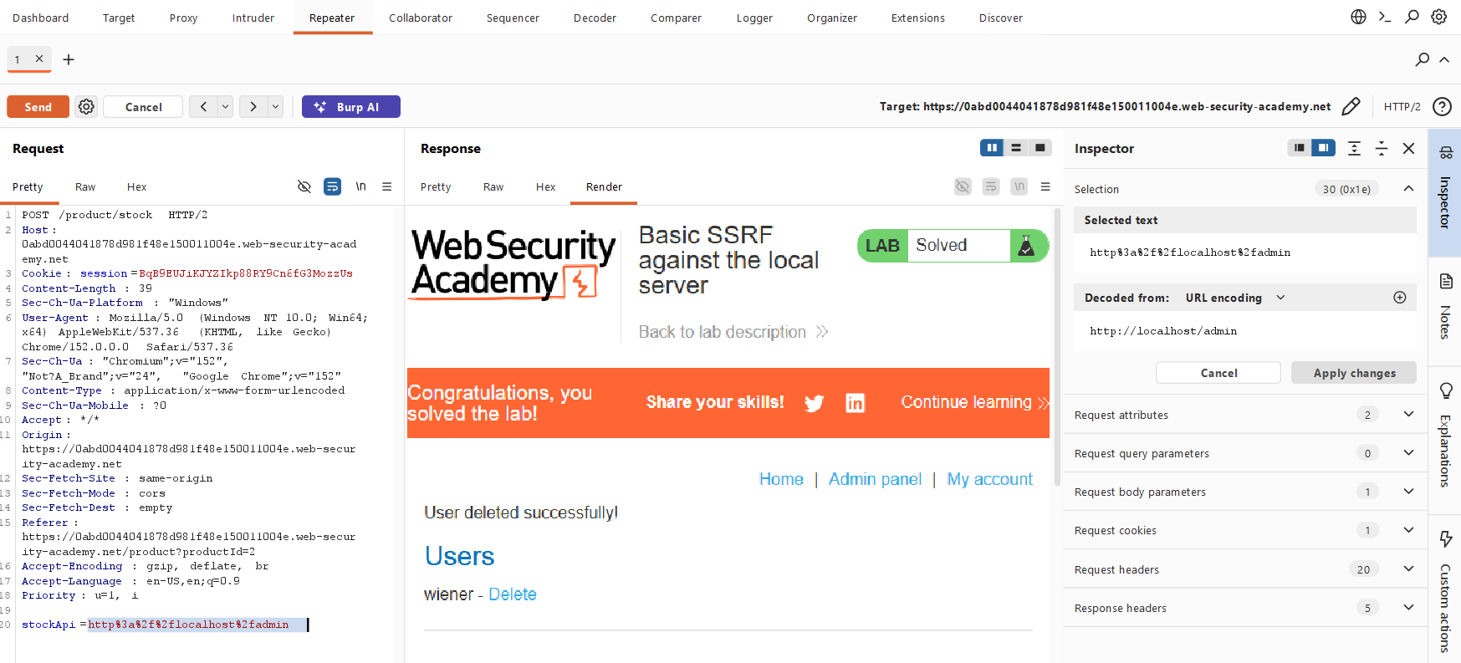
🔍 Different Possibilities I Considered
During the testing process, I considered the following possibilities:
1. Directly accessing /admin
I first considered whether the admin interface could be accessed directly.
However, the lab behavior showed that the admin interface was protected.
The response indicated:
Admin interface only available if logged in as an administrator, or if requested from loopback
So direct access was not sufficient.
2. Testing the Stock Check Request
The stock check functionality was more interesting because it accepts a URL through:
stockApi
This suggested that the backend was making a server-side request.
3. Accessing localhost
The lab explicitly suggested:
http://localhost/admin
I therefore tested whether the vulnerable server could access its own internal admin interface.
The response returned the admin page, confirming the SSRF behavior.
4. Finding the Delete Endpoint
Once the admin page was accessible, I inspected its HTML to find how the application deletes users.
The response revealed:
/admin/delete?username=carlos
This provided the exact endpoint needed for the final step.
5. Sending the Delete Request Through SSRF
Instead of accessing the delete endpoint directly from the browser, I supplied it through:
stockApi
This caused the vulnerable server to make the internal request.
⚡ How the Vulnerability Was Confirmed
The SSRF vulnerability was confirmed through several observations.
Normal request
The stock check normally returned a stock quantity such as:
708
and:
714
Modified request
The stockApi parameter was changed to:
http://localhost/admin
The application then returned the internal administration interface.
Internal admin access
The response contained:
Admin panel
and users such as:
wiener
carlos
Internal delete endpoint
The HTML revealed:
http://localhost/admin/delete?username=carlos
Successful exploitation
That URL was supplied through the SSRF-controlled stockApi parameter.
The PortSwigger lab then displayed:
LAB Solved
Finally, requesting:
http://localhost/admin
again showed that carlos was no longer present.
Therefore, the SSRF vulnerability was successfully exploited.
🎯 Root Cause
The root cause of the vulnerability is that the application's stock check functionality allows a user-controlled URL to be supplied through the:
stockApi
parameter.
The backend then makes a request to the supplied URL without adequately restricting which destinations can be accessed.
Because the server could make requests to:
http://localhost/
the attacker could make the server access an internal administration interface that was protected from normal external access.
The vulnerable flow can be represented as:
User
|
| stockApi=http://localhost/admin
↓
Public Web Application
|
| Server-side request
↓
localhost
|
↓
/admin
The same mechanism was then used to reach:
http://localhost/admin/delete?username=carlos

🛡️ Remediation
To prevent this type of SSRF vulnerability, applications should avoid allowing arbitrary user-controlled URLs to be requested by the server.
1. Use an allowlist
Only permit requests to known, trusted destinations.
For example:
Allowed:
https://trusted-stock-service.example/
Blocked:
http://localhost/
http://127.0.0.1/
2. Block internal destinations
Requests to internal addresses should be restricted, including:
localhost
127.0.0.1
::1
and other internal/private network destinations where appropriate.
3. Validate URLs server-side
The server should parse and validate the complete destination rather than relying only on simple string checks.
4. Restrict network access
The application server should have limited network access to sensitive internal services.
Network segmentation can reduce the impact of SSRF vulnerabilities.
5. Protect administrative functionality
Administrative endpoints should use strong authentication and authorization.
Security decisions should not rely only on whether a request originated from the loopback interface.
6. Avoid unnecessary URL fetching
If the application does not need arbitrary URL fetching, the functionality should be redesigned to avoid accepting user-controlled destinations.
📚 Key Learning
Through this lab, I learned:
- What Server-Side Request Forgery (SSRF) is.
- How SSRF can be discovered through application functionality that fetches URLs.
- How to identify a potentially vulnerable URL parameter.
- How to capture HTTP requests using FoxyProxy and Burp Suite.
- How to move a captured request into Burp Repeater.
- How to modify parameters and observe server behavior.
- How localhost can expose internal services through SSRF.
- How internal admin interfaces may have different access controls.
- How inspecting HTML responses can reveal additional endpoints.
- How the same SSRF mechanism can be used to reach an internal action endpoint.
- How to verify the final impact of a vulnerability.
🎓 My Biggest Takeaway
My biggest takeaway from this lab is that SSRF is not just about accessing internal pages.
The real danger comes from what the attacker can do after reaching an internal service.
In this lab, the vulnerable parameter initially appeared to be used only for checking product stock:
stockApi
But because the server trusted the supplied URL, it could be redirected toward:
http://localhost/admin
and eventually:
http://localhost/admin/delete?username=carlos
This shows why server-side URL fetching functionality needs strong validation and strict destination controls.
🏁 Conclusion
I successfully completed the Basic SSRF against the local server lab on PortSwigger Web Security Academy.
The vulnerable stockApi parameter allowed the application server to make requests to internal resources.
By changing the destination to:
http://localhost/admin
I accessed the internal administration interface.
After inspecting the returned HTML, I identified the deletion endpoint:
http://localhost/admin/delete?username=carlos
I then supplied this URL through the vulnerable stockApi parameter and successfully deleted the user carlos.
The lab displayed:
LAB Solved
and a final verification confirmed that carlos was no longer listed.
🧠 Learning Summary
Area | What I Learned
Vulnerability | Server-Side Request Forgery (SSRF)
Difficulty | Apprentice
Attack Surface | Stock check functionality
Vulnerable Parameter | stockApi
Initial Target | http://localhost/admin
Internal Service | Local administration interface
Target User | carlos
Delete Endpoint | /admin/delete?username=carlos
Tool | Burp Suite
Proxy | FoxyProxy
Testing Tool | Burp Repeater
Verification | carlos disappeared from the admin user list
Result | ✅ Lab Solved

🔐 Vulnerability Type
Server-Side Request Forgery (SSRF)
OWASP Category: Server-Side Request Forgery
Primary Impact:
- Access to internal services
- Bypass of network-level restrictions
- Interaction with internal administrative functionality
- Potential unauthorized actions against internal resources

